Name: ___poorab gangwani_______________

Section: _______2B__________

Enrollment #: _____cs191092________

**LAB # 3**

**Experimental Verification of Ohm’ s Law and Voltage & Current Measurement**

**Lab Objectives:**

* To learn how to measure voltage
* To learn how to measure current
* To experimentally verify Ohm’s Law.

**Apparatus Required:**

* DC Power Supply
* Digital Multimeter
* Resistors
* Connecting wires
* Bread board

**PRE-LAB:**

**Measuring Voltage:**

Voltage is measured **across** a device by connecting the meter probes on the nodes across (parallel) the device.

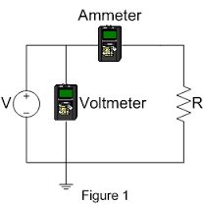

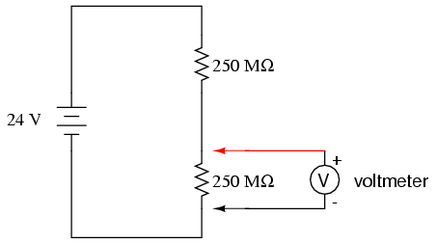

*Fig. 3.1: Voltage measurement Fig. 3.2: Current measurement*

**Measuring Current:**

Current is measured **through** a device by connecting the meter inside a circuit (i.e. in series).

**Ohm’s law:**

Ohm’s lawstates that the current (I) flowing through a component is directly proportional to the voltage (V) across it, if resistance (R) of that component is constant. Mathematically this relation is represented as,

$V=IR$………………………….Eq. 3.1

Electric devices which follow Ohm’s law are said to be Ohmic devices. Resistors fall under the category of Ohmic devices. Each resistor has a certain color code, which tells us about the electrical resistance of that resistor in ohms (Ω).

**IN-LAB:**

**LAB TASK 1: Measuring voltage**

1. Develop the circuit of fig. 3.3 on breadboard and measure the voltage according to fig. 3.4.
2. Set voltage to 5V
3. Take R1=10 KΩ

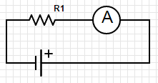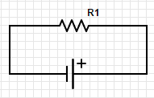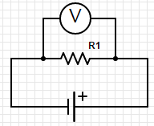

*Fig. 3.3 Fig. 3.4 Fig. 3.5*

Voltage (V)= __5V___________

**LAB TASK 2: Measuring current**

1. Now break the circuit and insert the probes of multimeter in between as in fig. 3.5.

Current (I)=______500 rA______

**LAB TASK 3: Ohm’s law**

1. Develop the circuit shown in Fig 3.6 on a bread board. Use the resistor provided to you by the Lab Assistant.
2. Progressively increase the DC power supply’s voltage from 1V to 10V and record the current using a series connected ammeter.
3. Write your experimental results in table 3.1
4. Plot the experimental values of voltage and current, with voltage (V) on the y-axis and current (I) on the x-axis.

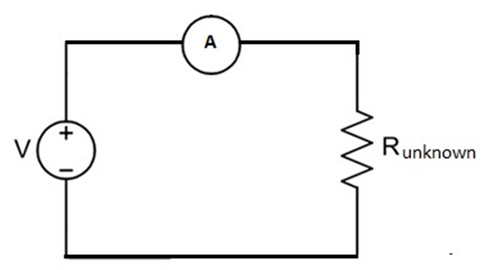

*Fig 3.6: lab task 3*

*Table 3.1: lab task 3*

|  |  |
| --- | --- |
| **DC Supply Voltage (V)** | **Current (I)** |
| 1V | 100mA |
| 2V | 200mA |
| 3V | 300mA |
| 4V | 400mA |
| 5V | 500mA |
| 6V | 600mA |
| 7V | 700mA |
| 8V | 800mA |
| 9V | 900mA |
| 10V | 1A |

This part was told to be skipped as informed by madam sidra

Q.1) What type of graph do you get?

_____________________

Q.2) How would you describe the relationship between voltage and current?

____________________________________________________________________________

Q.3) Calculate the slope of the plot and show your calculations in the space provided.

Slope: ______________

Unknown = __________ Ω

**Conclusion:**

**__________________________________________________________________**

**__________________________________________________________________**

**_________________________________________________________________**



Name: __________________

Enrollment #: _____________

**POST-LAB ASSIGNMENT# 3**

Q.1) How would you describe the voltage-current relationship of an Ohmic device?

**current flowing through a conductor is directly proportional to the potential difference across it’s ends if the temperature and physical conditions remain the same.**

Q.2) Is ohm’s law applicable to non-linear devices?

_______NO____________

Q.3) Determine the values of R1 if a current of 3A is flowing in the circuit.

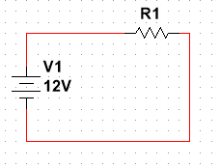 R1 = ?

V1=12V

I1=3A

V=IR

V1 = I1 x R1

R1=V1/ I1

R1= 12/3

R1=4